I created Maven/RestAssured framework, java class First.java contains testcase. POM.xml files contains all dependencies that needed to run Cucumber/Junit framework, for UI Testing, API Testing, DataBase Testing. I did project in eclipse and transferred to IntelliJ, that’s why path to First.Java so long :

Assessment\src\main\java\com\Conduct

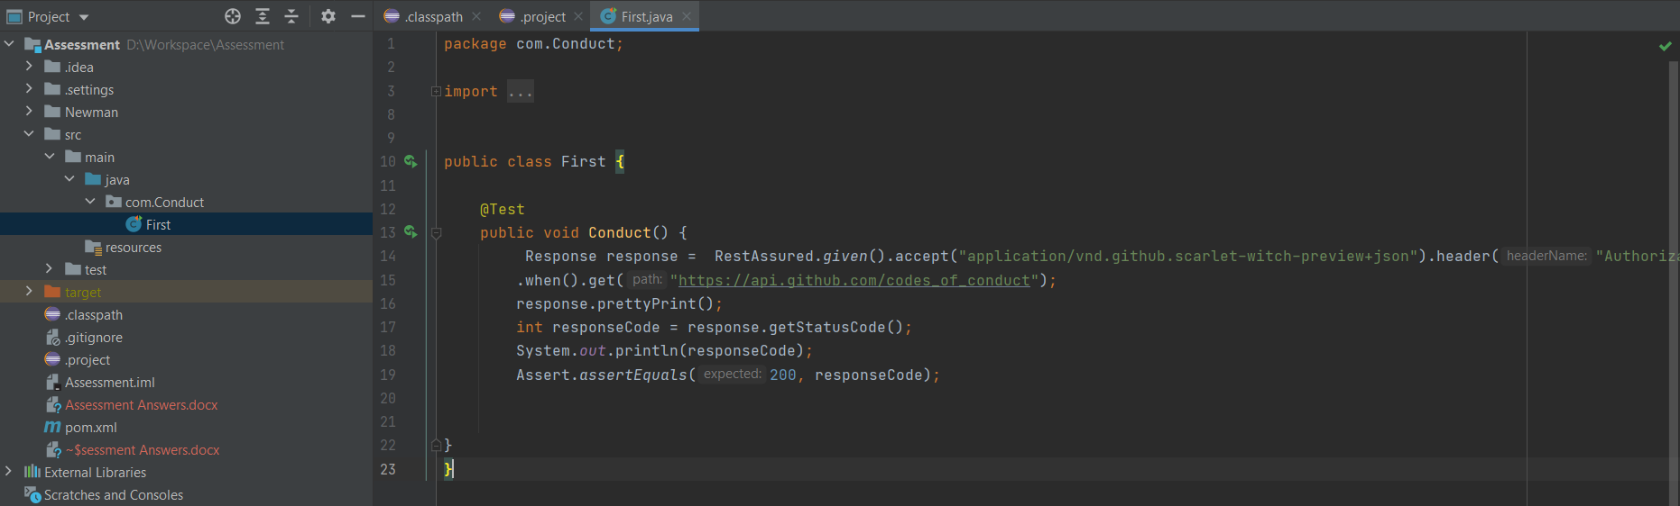

In Maven Folder Structure you can see folder “Newman” that’s where I stored exported Postaman collection in Json format “AuthentificztionPostman_collection.json”, also printscreen of newman’s test results, and newmans report in jason format “outputfile.json”

Framework pushed to NewmanRestAssured repositry on my github, name is Fazliakhmedov.

https://github.com/Fazliakhmedov/NewmanRestAssured

* What concerns would you have from a testing perspective?

How to authenticate to git API, I used Postman to run test manually and authorize: OAuth2 type of Authorization(or pass headers Authorization) and GitHub token to access GitHubs API. Passed headers and Authorization I successfully received Default response.

Create Maven Project for automation with help of RestAssured Libraries.

Create POM.xml file with needed dependencies to execute the test.

Create java class with actual test, and RestAssured.

Run Test.

Postman/Newman framework, Authorization, and export of collections, running collections with Newman, and retrieving newman’s results.

Authorization passed with Headers Access : application/vnd.github.scarlet-witch-preview+json and Authorization – Token.

* How would you go about tackling the QA for this work

By criteria of testing life cycle

Requirements, Planning, Analysis, Design, Implementation, Execution, Conclusion, Closure

* What sort of tests would be worth describing or worth automating

Test cases I picked form postman Snippets.

* What tools would you use?

IntelliJ, Eclipse, Maven, RestAssured, Junit, Postman, node.js